
School of Accountancy
Iziko Locwangciso-mali
Skool vir Rekeningkunde

FINANCIAL ACCOUNTING 178

IAS 19 – EMPLOYEE BENEFITS

Theory

Material
- IAS 19 – Employee benefits
- IFRS 18 – Presentation and Disclosure in financial statements

Learning Outcomes

- To classify employee benefits into the categories according to IAS 19

- To account for short term benefits, post-employment benefits: defined contribution plans and termination benefits in terms of IAS 19

- To motivate and explain the accounting of short-term benefits, post-employment benefits: defined contribution plans and termination benefits

- To disclose short term benefits, post-employment benefits: defined contribution plans and termination benefits in the financial statements

CLASS EXAMPLE 1: Salaries

An employee is entitled to a gross salary of R20 000. However, there are deductions that will be subtracted from this gross salary and then the net salary will be paid to the employee.

Gross salary | 20 000
Deductions:
Medical aid contribution  (Employer pays to Medical aid scheme on behalf of employee) | (1 800)
UIF (R20 000*0.01 = R200, limited to R177.12)  (Employer pays 1% of salary to SARS on behalf of employee) | (177.12)
Tax  (Employer pays tax to SARS on behalf of employee) | (4 500)
Net salary | 13 522.88
The employer also has to contribute 1% of salary for UIF*  (matches whatever the employee paid) | (177.12)

Dt Employee benefits (P/L) 20 177.12 (20 000 + 177.12)
Cr Bank (SFP) 13 522.88 (to employee)
Cr Bank / Creditors (SFP) 1 800.00 (to medical aid)
Cr Bank / SARS (SFP) 177.12 (UIF to SARS)^
Cr Bank / SARS (SFP) 4 500.00 (Income tax to SARS)
Cr Bank / SARS (SFP) 177.12 (UIF to SARS)^

^ Kept in the same GL account because it is paid over at the same time (Employer and Employee contribution).

* https://www.sars.gov.za/types-of-tax/unemployment-insurance-fund/

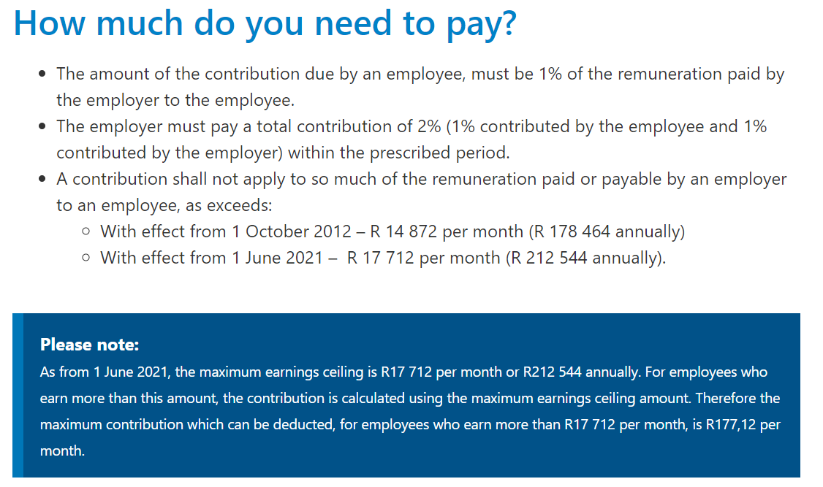

LEAVE PROVISION

Principles
- Only make provision for unused accumulating leave
- Take into account the probability that the days will be used before they expire (only for accumulating non-vesting)
- Make provision at daily tariff that will be applicable when the leave is expected to be taken (this is usually the following year’s daily tariff, after salary increases)

Steps

- Calculate the closing balance of the leave provision
- Calculate number of unused days on YE
- Determine how many of the unused days will be used in the future, based on expectations (only for accumulating non-vesting)
- Determine the daily tariff that will be applicable when the leave will be taken
CLOSING BALANCE = unused days on YE (for non-vesting: adjusted for number that will be taken, based on expectations) x daily tariff at which it will be paid

- Calculate the movement in the leave provision, and account for it in P/L (Movement = Closing balance minus Opening balance)

CLASS EXAMPLE 2: Accumulating, vesting (e.g. vacation leave)

Salary per month = R10 000
25 workdays per month.
Get 15 days’ vacation leave per year.
Unused vacation leave can be carried over to the next year and is payable in cash when the employee resigns.

Year 1
Carry over 3 days to next year (only used 12 days leave).

Year 2
Take 3 days leave from previous year and assume there are no accumulating leave days at the end of Year 2.

CLASS EXAMPLE 3: Accumulating, non-vesting

A company has 10 employees. Each employee receives R10 000 pm salary in the year ended 31 December 2013, and 15 days’ vacation leave. Unused vacation leave can be carried over, but expires at termination of employment (cannot be paid out).

On 1 January 2013 the leave provision was R25 000 (in total). On year-end there was 100 unused days (in total). It is expected that 80% of the unused leave will be taken before termination of employment. Salary increases of 10% has been announced for the 2014-year. Assume that each month has 25 working days.

CLASS EXAMPLE 4: Non-Accumulating (e.g. sick leave)

Salary per month = R10 000
5 days sick leave a year. Unused sick leave cannot be carried over to the next year.

